Code Review 2: Netlogo Fire Ants Simulation

Daniel McDonough, 4/17

# Introduction:

This code review was done with code from Elizabeth (Liz) Raine. Liz is writing a simulation for invasive species in Netlogo how fire ants bond together to create a rafts during floods. The following review discusses the behavior of her ants and gravity.

# Code Review:

Figure 1 shows the functionality of the simulations turtles (or ants). The ants are meant to climb above each other when they accupy the same space and fall if there is no space below them. Initially, the ants constantly climbed up due to check of the other ants being .25 of the next patch instead of 1. Due to the constant size of a patch being 1 having anything less than that would have the patch detect the turtle on it therefore constantly climb. Likewise, the fall function also checked for 0.25 causing the same problem where there is never a turtle below the initial turtle asking.

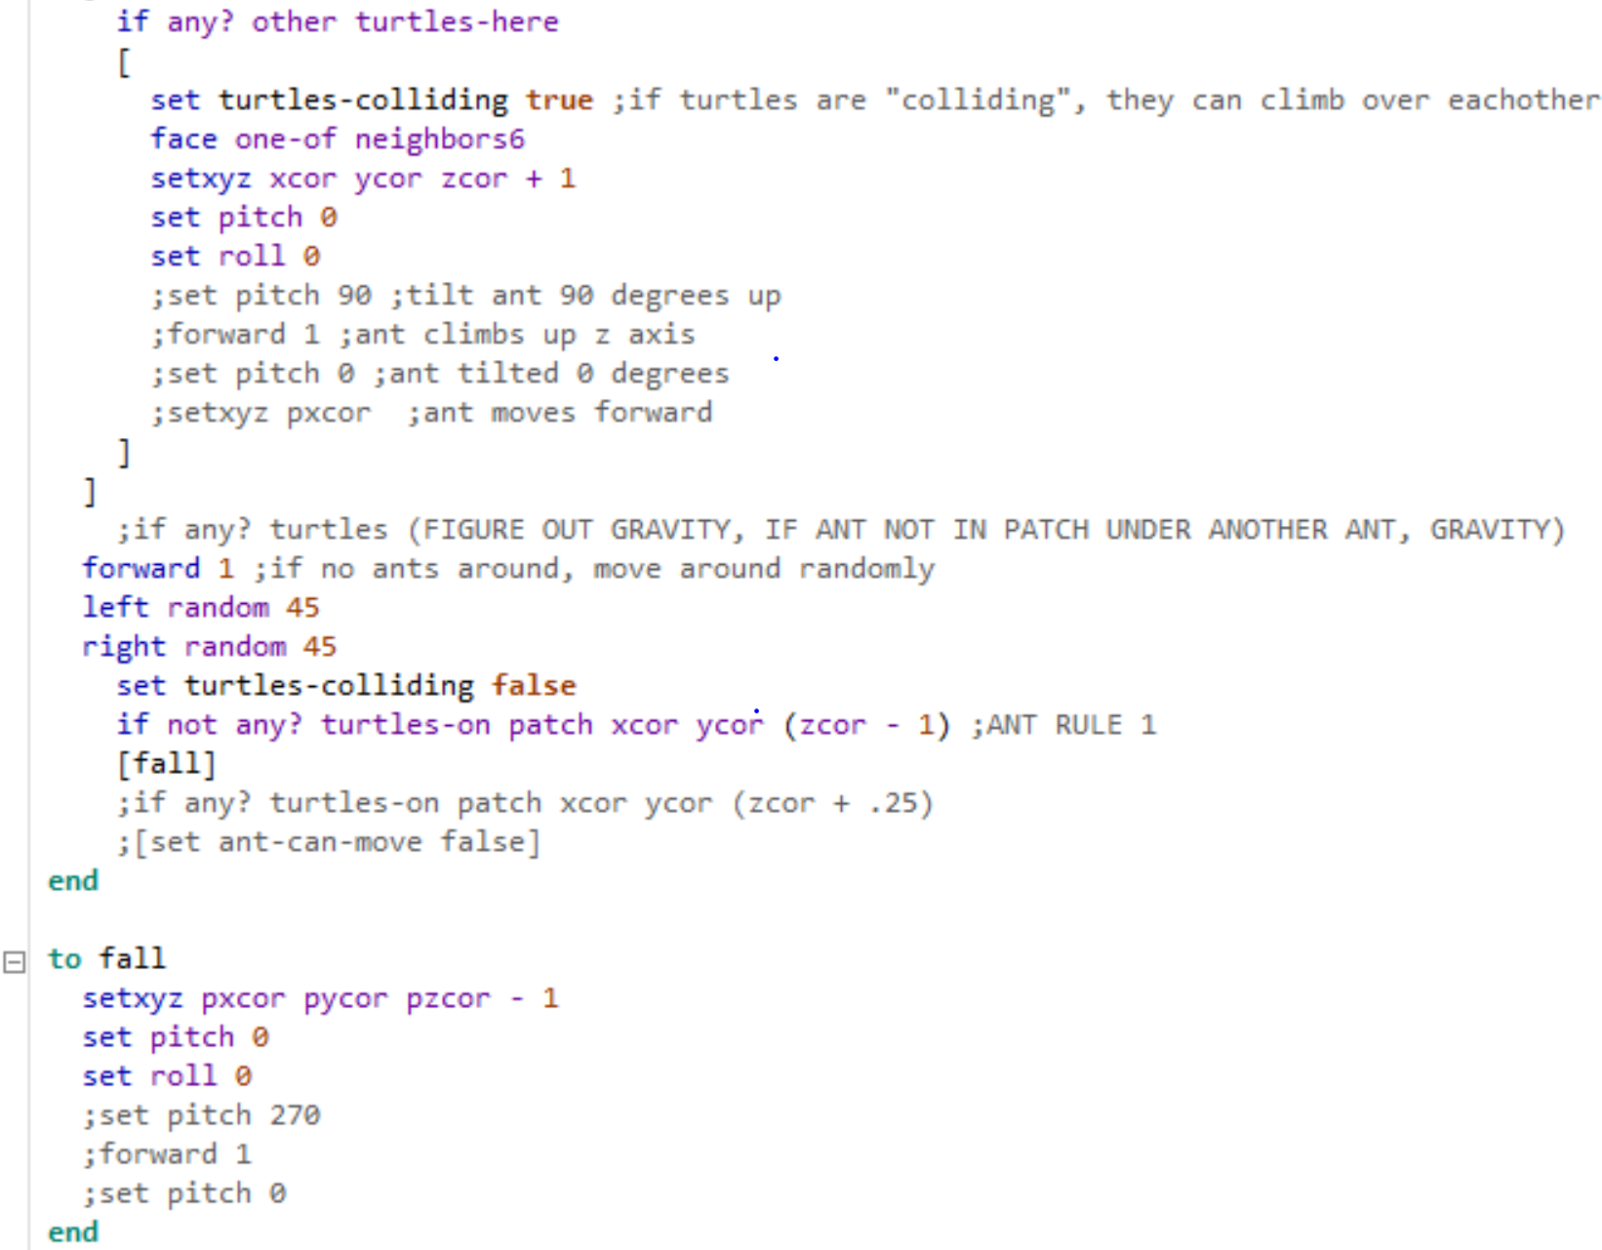

Figure 1: Code in the Ant and Gravity Behavior.

# Discussion and suggestions:

Upon review of this code, I would also suggest making a links between the ants so that ants go towards each other. Of course this only works if the ants do seek each other out when forming a raft. This would allow more accurate movement of the ants than a random left and right turn. It would also be useful to add a cap on water level to prevent the simulation from “flooding”.

Links Resource: <https://ccl.northwestern.edu/netlogo/docs/programming.html#links>